Power Platform Senior Technical Expert Consultant
MS Certified - 10 years of experience (8 years with Abalon)
FUNCTIONAL SKILLS |  |  | CERTIFICATIONS  Microsoft 70-488  SharePoint2013
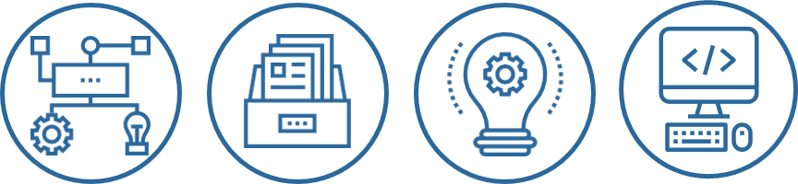

- Companies workflows
- DMS
- Design and Engineering
- Development

TECHNICAL SKILLS
Power Platform – O365  PowerApps / PowerAutomate |  | PowerShell / PnP
SharePoint  SP 2013 / SP 2016 / SP Online |  | Microsoft Dataverse
Teams
Flow Bot
Power BI

OTHERS SKILLS AND LANGUAGES
2023 : Speaker at MWCP 2023 and aMS Paris  Explain and demonstrate how to synchronise documents in between SharePoint and Dataverse  2021 : Speaker at MWCP 2021 and MS Virtual Marathon  Explain and demonstrate Responsive Canvas App on PowerApps  2020 : Speaker at MS Virtual Marathon and Power Saturday  Overview and first steps with the Teams connector under PowerPlatform  October 2018: Speaker at MWCP 2018  Connect Azure IoT Hub with a Raspberry PI to follow the evolution of a meat drying using sensors under Power BI.  Technical blog: Containing posts on various subjects  Containing posts on Power Platform, PowerShell, SharePoint and C# solutions.  Web adress: http://www.ludovicperrichon.com |  |  | 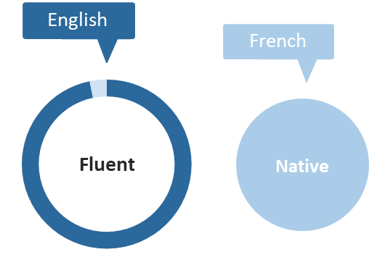

EXPERIENCES

Abalon : March 2015 to Today :
Nexity – Technical lead – Power Platform
2022 – February 2022 to Today
Projet : Develop small and medium PowerPlatform project with Dataverse under the “Build it run it” team
Mission | - Study business needs  - Write documentation to kick off the project  - Develop the project  - Deliver and follow bug tracking on the project  - Train the current team with PowerPlatform development

TotalEnergies / Accenture – Office 365 – Power Platform Expert
2021 – July 2021 to February 2022
 | Projet : Technical Studies on PowerPlatform Applications, On and Off-shore Team management
 | Mission | - Technical studies on multiple applications  - Following development and remote Team management in France and India  - Following project with business
Mitsubishi Electrics – Office 365 – Power Platform Technical Expert
2021 – July 2021 to Today
 | Projet : Study and implement PowerApps Canvas app with Dataverse
 | Mission | - Study and implement two projects, one to manage items returning by the customer service and one to let commercial enter KPI to identify futur commercial goals  - Manage and deploy solutions into multiple environment  - Create Dataverse structure (Tables, columns, Security Roles…)  - Create Multiple Canvas App  - PowerAutomate flow to import data from csv from SAP  - Read Outlook calendar events
Assala Energy – Office 365 – Power Platform Technical Expert
2021 – April 2021 to June 2021
 | Projet : Study and remake multiples SharePoint Classic site to SharePoint Modern site
 | Mission | - Styudy and remake 4 sites  - Remake SharePoint Designer Workflow into PowerAutomate Workflow  - Remake InfoPath form into PowerApps form  - Remake SharePoint Classic site into SharePoint Modern Site  - Manage a junior developer on the project
Lesaffre – Developer – Power Platform & Dataverse
2021 – January 2021 to March 2021
 | Projet : Developer on a project to let users to enter monthly data to make KPI.
 | Mission | - Develop Dataverse environment (Tables, columns, security roles …)  - Implement Canvas App with PowerApps
Assala Energy – Office 365 – Power Platform Technical Expert
2021 – January 2021 to March 2021
 | Projet : Study and Implementation of a SharePoint site containing PowerAutomates flows and a PowerApps form to manage budget aprovement.
 | Mission | - Study business need to make a technical proposal  - Implement SharePoint site using Powershell and PnP Script  - Implementation of SharePoint form using PowerApps containing business rules  - Implementation of business flows to manage the approval process
UFF Banque – Office 365 – Power Platform Technical Expert
2020 – November 2020 to december 2020
 | Projet : As part of the management of commercial brochures for its customers : Implementation of multiple PowerShell scripts and PowerAutomate flows to synchronie document in between a web server and a SharePoint Online site.
 | Mission | - PowerShell script using PnP and a UFF Banque API, to check and synchronise documents in between server and SharePoint Online  - PowerAutomate flow to arrange files into right folder, based on a given json from teh UFF Banque API.
Assala Energy – Office 365 – Power Platform Technical Expert
2020 – October 2020
 | Projet : Application migration from Classic SharePoint with SP Designer Workflow 2010 and InfoPath form to Modern SharePoint
 | Mission | - Study of the time to remake the project  - Remake SP Designer Workflow 2010 into PowerAutomate flows  - Remake Infopath form into PowerApps  - Create script to migrate date from Classic SharePoint to Modern
Coriance – Office 365 – Power Platform Technical Expert
2020 – Septembre 2020
 | Projet : Implementation of the « Téléalarme » application, which notify issue on equiments (mostly heating and cooling) to technician, who, in that case, will quickly operate maintenance.
 | Mission | - Implementation PowerAutomate flow  - Receive issue by mail and identify the equipment  - Identify the technican depending on different parameters (location, time …)  - Send email and phone call, via InfoBip
Total / Devoteam – Office 365 – Power Platform Technical Expert
2019 – From September 2019 to August 2020
 | Project: Under the Lift Center Team, design and engineering multiples solutions with the Office 365 Power Platform.
 | Mission | - Design and engineering solution  - Development in two weeks’ time solutions with PowerApps, PowerAutomate and/or Power BI  - Write documentation if needed  - Developed around 15 projects
Total / Devoteam – Office 365 – Power Platform Technical Expert
2019 – From September 2019 to August 2020
 | Project: Under the Lift Center Team, design and engineering multiples solutions with the Office 365 Power Platform.
 | Mission | - Design and engineering solution  - Development in two weeks’ time solutions with PowerApps, PowerAutomate and/or Power BI  - Write documentation if needed  - Developed around 15 projects
Total / TCS – SharePoint technical Expert
2019 – From May 2019 to September 2019
 | Project: Technical Expert on SharePoint 2013 solution and on SharePoint 2013 with FileShares migration to SharePoint Online.
 | Mission | - Design and engineering requests  - For migration, POC development and presentation of studies results  - Develop and implement SharePoint 2013 solutions
CSV 2 List – Internal project – SharePoint Online Development
2018 – January 2018
 | Project: To familiarize with TypeScript and React, creation of a SharePoint Add-in which upload data from a CSV to SharePoint list.
 | Mission | - Use of Node and Yoeman package  - TypeScript / React development  - Workbench discovery  - Package the applicationn
BNP Paribas / Aerow – Technical Lead
2018 – From January 2018 to May 2019
 | Project: Technical lead on multiple projects under the SSC Team of BNP Paribas using SharePoint 2013 and 2016 with SharePoint Hostep App.
 | Mission | - Design and engineering requests  - Lead developers team based in India  - Write functional and technical documentation
Snecma / Safran – Project Owner / Functional and technical support
2017 – 6 months
 | Project: SharePoint expert for SNECMA, affiliate of Safran in building plane engine.
 | Mission | - Project owner on SharePoint project with third party service provider  - Technical and functional support to SNECMA’s employees  - Linking the different technical actors of a project
MBDA / Infeeny – SharePoint 2013 Development
2017 – 3 months
 | Project: Under the MBDA Digital Portal intranet project, which contains several sites collections and a languages management via SharePoint variations
 | Mission | - Development of web-parts allowing the display of elements by taking informations into the SharePoint search service.  - Custom actions development.  - Integrate web-parts and page-layouts as xml declaration.  - Custom content types creation.
FFB / Altamys – SharePoint 2013 Development
2016 / 2017 – 9 months
 | Project: Under the FFB (Fédération Française du Batiment – Building French Federation) intranet project, which contains a news part linked with FFB informations and an Electronic Document Management part.
 | Mission | Grouping information, aspx, wiki pages and documents for miscellaneous users:  - Web-parts, Event receivers, Customs actions and SharePoint mail alert templates development.
Dassault / Orange Business Services – SharePoint 2010 Development
2015 / 2016 – 7 months
 | Project: Falcon Device Registration & Falcon Store Admin - Human-machine interfaces development with SharePoint 2010 web-parts for the Devices in Falcon plane from Dassault.
 | Mission | - .NET, C#, MVP (Model, View, Presenter) and Javascript/jQuery development
BPI / Be-Cloud – SharePoint Online Development
2015 – 3 months
 | Project: Add-ins development which are part of the SharePoint Online platform for the Toucan 2.0 project. Toucan was on old application on Lotus Note which follow companies and employees on social plan in accordance with the French law.
 | Mission | - Development of a prospecting campaigns generator (SharePoint Provider Hosted App).
Total / TCS – Qualification of SharePoint incident at level 3 support
2015 – 4 months
 | Project: Qualification of SharePoint incident at level 3 support on the WAT intranet portal for Total under SharePoint 2013
 | Mission | - Follow-up incident with an ITSM interface  - Analyze and investigation of the incident.

STUDIES
2012: UPPA – Anglet, FRANCE
Professional licence SIL (Système Informatique et Logiciel – IT Systems)
In internship with the company BiP Info.

2009: Audiovisual Bachelor – Biarritz, FRANCE
Technical engineering and exploitation of equipment

