Internal Digital Consultant

20 years of experience in corporate digital (intranet / collaboration)
  BUSINESS SKILLS |  |  | Digital business transformation  Deploying uses and Office 365 tools  Digital working








- Change management
- Digitalization / Process optimization
- Intranet (design, implementation, …)
- Project management
- Team management
- Communication
- Device and application design


Functional and technical skills
Office 365 Suite  Tools & uses master |  | WIX  Website creation
SharePoint  Any versions |  | Video, writing  Communication & publication
Office 365 administration  Tenant management, configuration | 


EDUCATION AND LANGUAGES
English
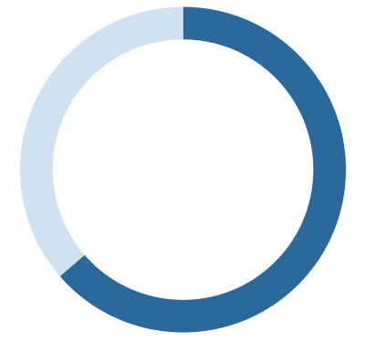
1995 : Institut Administration des Entreprises - LILLE  DESS – Gradute degree in Project Management  1993 : Université Sciences et Technologies de LILLE  MIAGE – Master’s degree in computer science applied to business management    PUBLICATIONS |  |  | 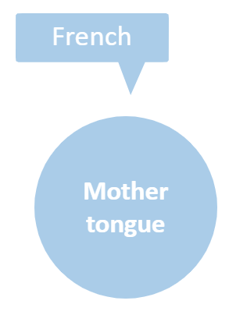  Oral and written mastery
- Writer of the website http://www.digital-inside.fr
- Author of the book “Le digital interne en entreprise” published by Mardaga (June 2019)
- Author of the books “Les projets Informatiques autrement” and “Penser autrement l’intranet, la digitalisation & les RSE” https://www.digital-inside.fr/publicationlivres
- Author of the White Paper “Comprendre le digital interne avec Office 365 et ses opportunités”
https://www.digital-inside.fr/livresblancs

EXPÉRIENCES


TOTAL – Support for adoption
September 2019 – In progress (intermittently)
 | Project: Support the Total Group's LIFT CENTER in charge of employee support at Office 365.
 | Missions |  | - Consulting support for deployment  - Digitalization of teams  - Raising team awareness of the benefits of Office 365
BOUYGUES SA (Holding) –Office 365 Strategy / Teams / other tools
September 2018 – In progress (intermittently)
Project: Supporting the IT department of the Bouygues group's head office in the deployment of Office 365 solutions for head office staff.
Missions |  | - Implementation of a SharePoint portal to carry the communication and office support  - Writing awareness-raising and explanatory articles  - Production of awareness-raising videos  - Animation of a digital approach to the management assistants of the holding company  - Advice and support on the deployment strategy of Office 365
ELECTRE – Realization of the intranet
Janvier 2020 – In progress
 | Project: Develop the company's intranet.
 | Missions |  | - Definition of the Intranet structure  - Creation of the “container” and integration of the content  - Coaching and advice in the associated strategy
GRTGaz – Yammer / Digital Working / Office 365 Strategy
2015 - 2019 (4 ½ years)
Project: Accompanying GRTgaz (European leader in gas transmission) in its digital transformation. For more information on this mission, please visit: http://www.digital-inside.fr/grtgaz
Missions |  | - Launch of GRTGaz's Social Network with Yammer  - Digitalization of the Sales Department (SharePoint / Yammer)  - Digitilization of teams and management with the entire range of Office 365 tools (Digital Working)  - Defining GRTGaz's digital strategy with the management
UNIGRAINS – Intranet / Teams / Office 365 Strategy
June 2019 – In progress
Project: Implementation of the intranet and support for the digital strategy.
Missions |  | - Design and implementation of the corporate intranet with SharePoint  - Advice on digital communication within the company  - Accompanying the company in the deployment of digital uses with Office 365
CLIMESPACE (Engie) –Office 365 Strategy / Support for digital uses
2018 (1 month)
Project : Accompanying measures for the deployment Office 365.
Missions |  | - Accompanying the definition of an Office 365 strategy  - Setting up two digital devices with Sharepoint ans Teams within the team  - Supports writing / Texts / awareness-raising videos  - Coaching of the person in charge of support for Office 365 tools
OLIFAN Group – Intranet
2019 (1 month)
Project: Implementation of the intranet
Missions |  | - Design and implementation of the corporate intranet with SharePoint  - Intranet administrators training
PREVOIR (Life insurance) – Deployment of Office 365 tools
November 2018 – In progress (Intermittently)
Project: Supporting the ISD in the deployment of Office 365 solutions.
Missions |  | - Definition of the action plan and project management  - Implementation of a SharePoint space for the adoption of Office 365 tools  - Support for the deployment of tools  - Deployment advice
PMU – Office 365 / Teams
April 2018 – June 2019
Projext : Supporting PMU in the deployment of Office 365 tools, in particular Office 365.
Missions |  | - Deployment of the uses of Teams  - Implementation of a business portal for the “sales and customer communication” division  (find the testimony of the person in charge, Laurent Bocle, on page 77 of the book “Digital interne d’entreprise”)  - Implementation of a digital office automation portal with SharePoint, as part of the digitization of the office automation support.
FUN MOOC – Office 365 / Deployment of collaborative tools
2017 – In progress - (Intermittently)
Project : Supporting the company (SME) in the deployment of Office 365.
Missions |  | - Support for the opening of Office 365 services  - Design of an intranet  - Support in the use of Office 365 tools (Teams, Skype, etc)
COLAS – Collaborative Deployment Advice
2017 - (Intermittently)
Project: Advice on how to approach the collaborative in the context of a transformation project
Missions |  | - Situation audit  - Approach proposals  - Writing / construction of presentation materials
ORANGE – Accompanying the digitisation of office automation
2016 - (6 months)
Project: Orange's support in the office automation digitization project (read the white paper)
Missions |  | - Audit of the situation / drafting of recommendations  - Workshop animations  - Solution design: processes / interfaces
COVEA – Support for reflection on the Digital Workplace
2015 - (Intermittently)
Project: Bringing an external vision to the reflection on the building of the digital Workplace
Missions |  | - Constructive criticism of the approach  - Guidance proposals
Before 2015, employee of the BOUYGUES group (for 20 years).

BOUYGUES TELECOM – Head of Intranet Division
2000 - 2015 - (15 years)
Project: in charge of the IT department of the intranet division, integrating the intranet portal (depending on the period), Web business applications, the mobile intranet, the entire SharePoint service and the Enterprise Social Network (starting in 2011).
Missions |  | - Team management (up to 10 developers or SharePoint experts)  - Designer of 4 versions of the Bouygues Telecom intranet (out of 6) - several awards won (read: prix Coment, prix Nielsen Norman Group)  - Creator of the collaborative service offer since 2001 with SharePoint, deployment of the use of SharePoint, animation of support / awareness raising  - Designer of the main Web business projects in agile mode and development steering (example: eContrat)  - Designer of the Digitization of the Office Automation (cutting the hotline and replacing it with a digital service in less than 4 months): read the white paper on this experience  - Internal digital evangelist, initiator of a “working differently” approach from 2012 (working with CSR), still in force today.
SPIEG / COLAS – Project Director
1999 (18 months)
Project: Management of a project to develop a management tool (retrieval of payroll elements for the 400 COLAS sites)
Missions |  | - Design of the application  - Development steering  - Setting up support / training
BOUYGUES SA (holding) – IT auditor
1996 - 1998 (2 years)
Project: IT auditor within the Bouygues Group's internal audit department at the holding company, in charge of security, organisation and project audits.
Missions |  | - Design of audit assignments  - Conduct of audits in the field (in France and abroad– Asia in particular)  - Writing audit reports  - Results reporting

